Week 3 - Network Security Scan Report*
Student Name: [Azeen Ali]
Date: October 4, 2025
1. Introduction
The objective of this assignment was to use Nmap and Netstat to identify open ports and active network connections on the local machine. This helps in understanding which services are running and assessing basic network security posture.
2. Tools Used
- Nmap 7.99: For network scanning and service version detection
- Netstat: For displaying active network connections and listening ports
- Operating System: Windows 11
- Interface: Command Prompt
3. Methodology
Step 1: Nmap Scan
Command: `nmap -sV 127.0.0.1`
Purpose: To scan localhost for open TCP ports and detect service versions running on them.
Step 2: Netstat Scan
Command: `netstat -an`
Purpose: To list all active TCP/UDP connections and ports in listening state on the system.
Step 3: Save Output to Files
Commands:
nmap -sV 127.0.0.1 > nmap_scan.txt
netstat -an > netstat.txt
Purpose: To save scan results for documentation and analysis.
4. Results
Nmap Scan Results:
The Nmap scan detected 4 open ports on 127.0.0.1:
| Port | State | Service | Version |
| 135/tcp | open | msrpc | Microsoft Windows RPC |
| 445/tcp | open | microsoft-ds | Microsoft Windows SMB |
| 3000/tcp | open | http | http://Node.js Express framework |
| 5357/tcp | open | http | Microsoft HTTPAPI httpd 2.0 |
Screenshot 1: Nmap scan output

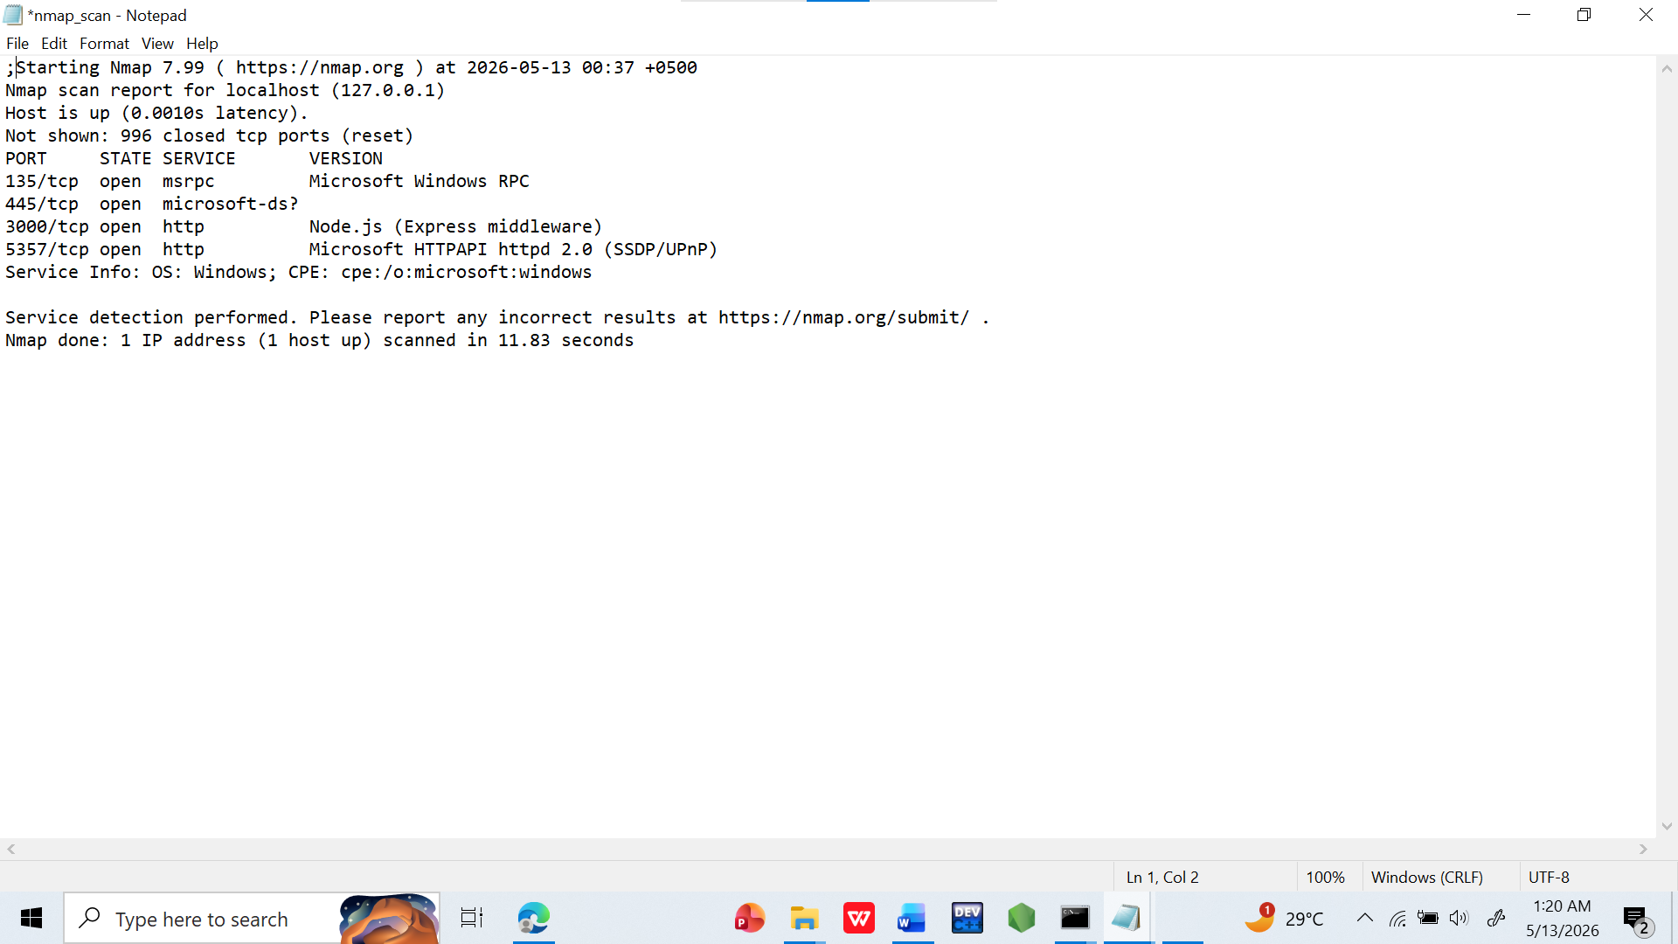

Netstat Results:
The Netstat command showed multiple UDP ports in LISTENING state. Key services identified:
- Port 5353: mDNS - Used by Apple Bonjour/Windows for service discovery
- Port 1900: SSDP - Used for UPnP device discovery
- Port 3702: WS-Discovery - Windows network discovery protocol
- Port 123: NTP - Network Time Protocol for time synchronization
Screenshot 2: Netstat output
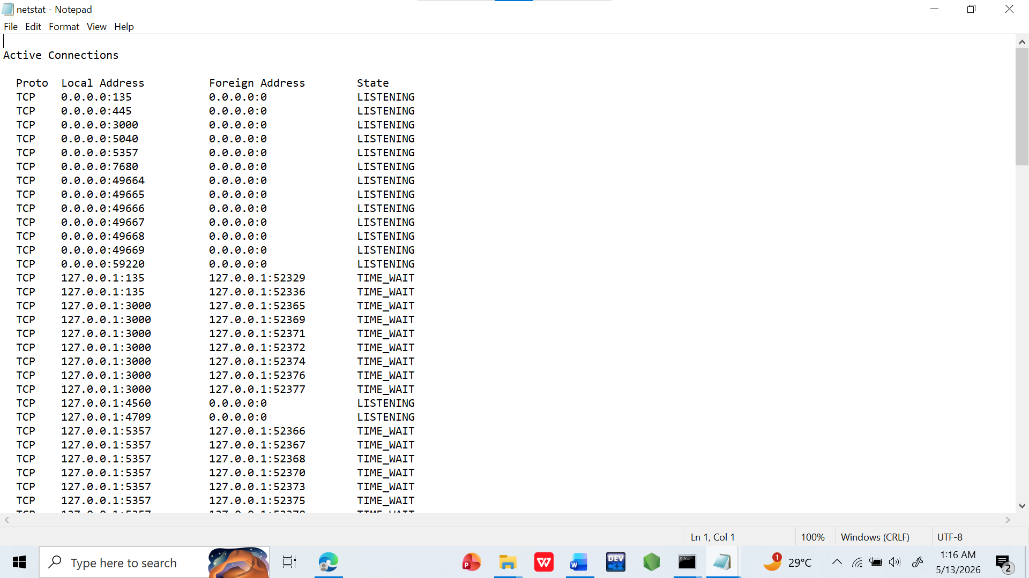
5. Analysis
1. Port 3000 is running a http://Node.js Express server. This is from the `app.js` file in the project directory and is expected for local development.
2. Ports 135 and 445 are standard Windows services for RPC and SMB file sharing. These should not be exposed to the internet without a firewall.
3. Port 5357 is Microsoft HTTPAPI, used by Windows services for web-based management.
4. The UDP ports shown by Netstat are normal Windows background services used for network discovery, time sync, and device communication. No suspicious connections were found.
6. Conclusion
The scan successfully identified all active services on the local machine. Port 3000 being open is normal for development work. All other ports belong to standard Windows services. For security, it is recommended to keep the Windows Firewall enabled to prevent external access to these ports. No immediate security risks were detected on localhost.
Attachments:
1. `nmap_scan.txt`
2. `netstat.txt`
3. Screenshot of Nmap scan
4. Screenshot of Netstat output

